1. Select the features you intend to use as independent variables and identify your target (dependent) variable. Split the data into training and testing sets.

**Pre-Processing**

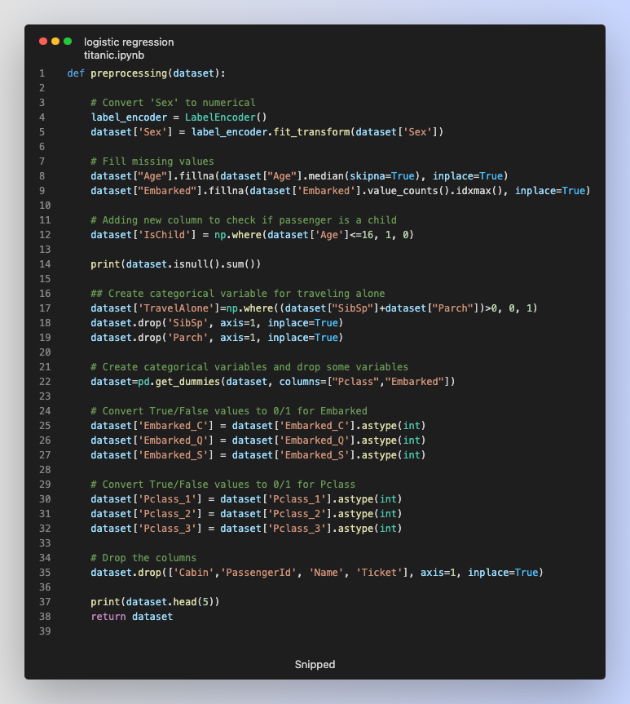

2. Utilize your model to make predictions on the testing data, calculate evaluation metrics such as accuracy and recall, and print the results.

**Logistic Regression Trainer -** This including Data Splitting

**Model Train and Evaluate** - On Test Dataset

3. Display the theta parameter values.

Theta parameter values **are Best parameters**

4. Create a DataFrame with 3 records (for 3 persons), use your model to make predictions, and print the predicted results using text descriptions such as 'survived' and 'not survived'.

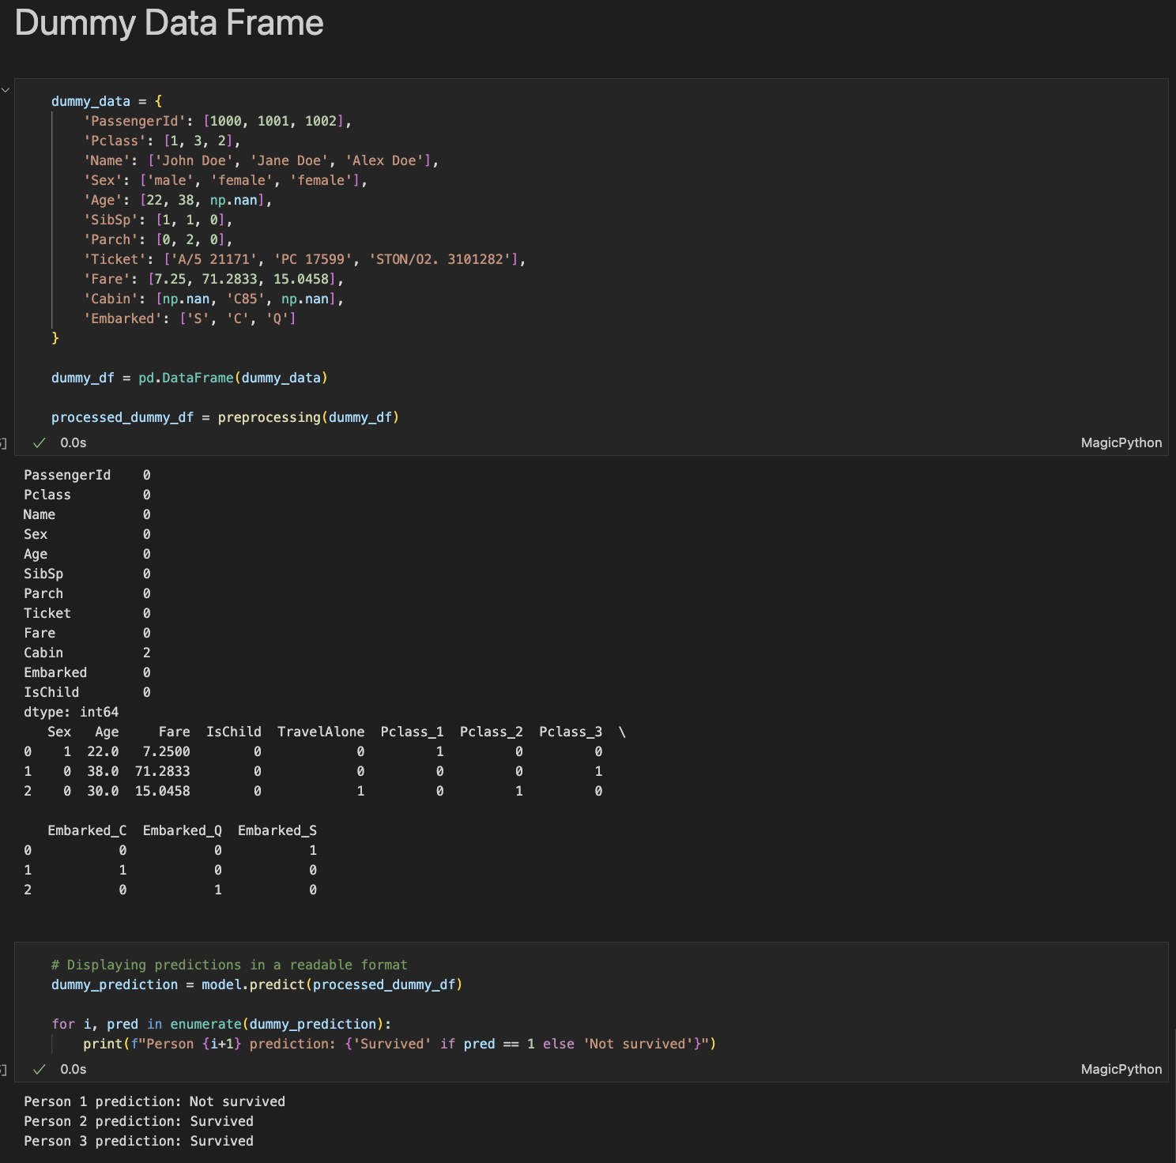

5. Alter the training/testing split fraction and the maximum iteration of the logistic regression model, observe and print the different outcomes.

Test with different **test size** and **max iter**

